29.56: The bar will experience a magnetic force due to the induced current in the loop. According to Example 29.6, the induced voltage in the loop has a magnitude 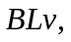which opposes the voltage of the battery, Thus, the net current in the loop is 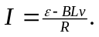 The acceleration of the bar is 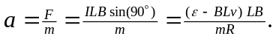
a) To find 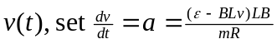 and solve for using the method of separation of variables:
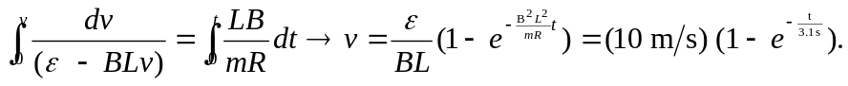
Note that the graph of this function is similar in appearance to that of a charging capacitor.
b)
c) When
d) Note that as the velocity increases, the acceleration decreases. The velocity will asymptotically approach the terminal velocity 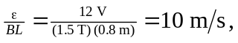 which makes the acceleration zero.

